Retaining innovation leadership, continuing on course of growth

EREMA Group ends financial year with significant increase in turnover

Around EUR 355 million in overall turnover, 350 extruders delivered creating an additional recycling capacity for 1.6 million tons of recycled pellets as a result - these are the impressive figures with which the EREMA Group was able to close the 2022/23 financial year in March. The innovations presented at K 2022 put the group of companies - consisting of EREMA Group GmbH and its subsidiaries EREMA, PURE LOOP, UMAC, 3S, KEYCYCLE and PLASMAC - in a strong position for their planned ongoing growth.

Ansfelden, 27. April 2022 - "With demand for recycled plastics remaining high, the past financial year brought many challenges that we needed to handle," says Manfred Hackl, CEO of EREMA Group GmbH. The challenges included persistent delays in the supply chain and unexpected supplier outages. Logistics and production processes had to be adapted several times as a result. The situation has improved significantly meantime as a result of these measures and more stable supply chains.

The production locations in Austria manufactured 270 extruders and delivered them to customers around the globe. Taking the whole group into consideration, this figure rises to 350 including the extruders from PLASMAC, the Italian subsidiary. The recycled pellet production capacity of all extrusion systems delivered in financial year 2022/23 adds up to around 1.34 million tonnes per year. On top of that there are around 130 additional components and modules such as filter systems and ReFresher anti-odour units.

Recycling innovations for even higher-quality pellets
K 2022 - the highlight trade fair of the past financial year - saw the EREMA Group launch seven new recycling systems and components. "For the first time, we brought all the companies in the group together on one stand, so we were able to provide an excellent overview of our wide range of products and services with the latest innovations as a one-stop-shop concept," says Manfred Hackl. These included the new INTAREMA® TVEplus® DuaFil® Compact recycling system and the EcoGentle® plasticising unit, which was also newly developed. Thanks to their gentle polymer treatment and significantly lower melt temperature, both extrusion innovations deliver effective advantages in terms of the quality of the melt, recycled pellets, and final product, as well as impressive energy efficiency in post consumer and PET recycling applications. The significance of these innovations for plastics recycling is underlined by the nomination of the DuaFil® Compact technology for one of this year's Plastics Recycling Awards Europe in the category Recycling Machinery Innovation of the Year. "We even received the first orders for these two new developments during the trade fair, which shows how well we are responding to the needs of the market," says Markus Huber-Lindinger, EREMA Managing Director.
The same applies to the READYMAC 1109 TVE machine made to stock by EREMA Group subsidiary UMAC, which is an impressive, quickly available all-rounder offering an attractive cost/benefit ratio for standard applications, as well as to the new ALPHA XS edge trim recycling machine for the inhouse recycling segment made by PLASMAC. The market launch of the deinking system presented at K 2022 by the EREMA Group company KEYCYCLE delivering a throughput of 1,200 kilograms per hour has been a success, as has the commissioning of a further unit sold to a film manufacturer.

40 years of EREMA
The beginning of the new financial year falls almost to the day on EREMA's 40th anniversary. On 14 April 1983, Helmut Bacher, Helmuth Schulz and Georg Wendelin founded EREMA Engineering Recycling Maschinen und Anlagen GesmbH, laying the foundation for the 40-year success story. During this period, the founders and their successors, together with the company's employees, have not only developed plastics recycling further, but have also made recycling possible in new applications, successfully making the journey from working out of a garage to becoming the world market leader. "While continuing on this course, we will also take this anniversary year as an opportunity to host various celebrations and thank our customers, partners and team of employees for their trust and commitment," says Manfred Hackl. One such event is the EREMA Discovery Day at the company headquarters on the 1st of June. This exciting event with live insights into the latest post consumer and PET recycling technologies will also see the official opening of the newly built research and development centre.

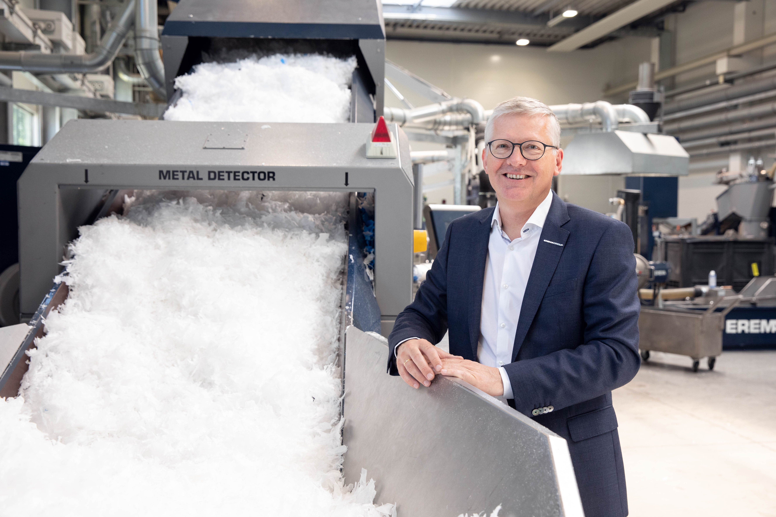
Photo: Manfred Hackl, CEO EREMA Group GmbH. (Photo credit: EREMA/Wakolbinger)

EREMA Group
Another life for plastic. Because we care.

Based in Ansfelden near Linz in Austria, EREMA Group is the world's leading manufacturer of plastics recycling solutions. With their companies EREMA, 3S, PURE LOOP, UMAC, PLASMAC, KEYCYCLE and PLASTICPRENEUR, they cover the entire spectrum of mechanical plastics recycling - from planning and engineering through to developing and manufacturing recycling technologies as well as producing system components and trading previously owned systems. These recycling solutions are currently operating in 108 countries worldwide and recycle approximately 19.5 million tonnes of plastic every year.

For further information please contact
Daniela Jung
Corporate Communication
EREMA Group
Unterfeldstraße 3
4052 Ansfelden, AUSTRIA
Phone: +43 732 3190-315; Email: public.relations@erema-group.com

